Day 04 | LeetCode Practice Notes

Problem 2913: Subarrays Distinct Element Sum of Squares I
Date: 15 October 2026 Difficulty: Easy Language: Python 3

1. What the question is asking
We are given a list of numbers. We need to look at every possible non-empty subarray. For each subarray, count how many different values appear, square that count, and add all those squares together.
A subarray must be continuous. For example, in [1, 2, 1], [1, 2] is a subarray. Taking only the first and last 1 is not a subarray because we skipped the middle element.

2. My example: nums = [1, 2, 1]
Subarray | Different values | Square of count
[1] | 1 | 1
[1, 2] | 1, 2 | 4
[1, 2, 1] | 1, 2 | 4
[2] | 2 | 1
[2, 1] | 2, 1 | 4
[1] | 1 | 1
Total = 1 + 4 + 4 + 1 + 4 + 1 = 15. This matches the accepted result.

3. How I approached it
- First, I choose a starting index i.
- Then, I create an empty set called seen. A set keeps only unique values.
- I move the ending index j from i to the end of the list.
- Every time I extend the subarray, I add nums[j] to the set.
- The size of the set tells me the distinct count. I square that number and add it to the answer.
- I repeat for each starting index and finally return the total.

4. Python solution
class Solution:
def sumCounts(self, nums: List[int]) -> int:
ans, n = 0, len(nums)

for i in range(n):
seen = set()
for j in range(i, n):
seen.add(nums[j])
count = len(seen)
ans += count * count

return ans

5. What the important lines mean
- range(n): tries each possible starting position.
- seen = set(): resets the unique-value tracker for each starting position.
- range(i, n): grows the current subarray one element at a time.
- seen.add(nums[j]): duplicates do not increase the number of distinct values.
- len(seen): gives the distinct count; count * count gives its square.

6. Time and space complexity
Time: O(n²) on average. The outer loop picks a start and the inner loop extends the subarray. Together they visit n(n+1)/2 subarrays. Set insertion is O(1) on average.
Extra space: O(n). For one start position, the set might store up to n different numbers.

7. What I learned today
I learned how to generate subarrays using two loops and how a set avoids counting repeated elements twice. A key detail is to create a new set inside the outer loop. Otherwise values from the previous starting index will affect the next answer.
Quick check: for nums = [1, 1], the three subarrays are [1], [1], [1, 1]. Each has one distinct value, so the answer is 3.

8. Accepted submission screenshot
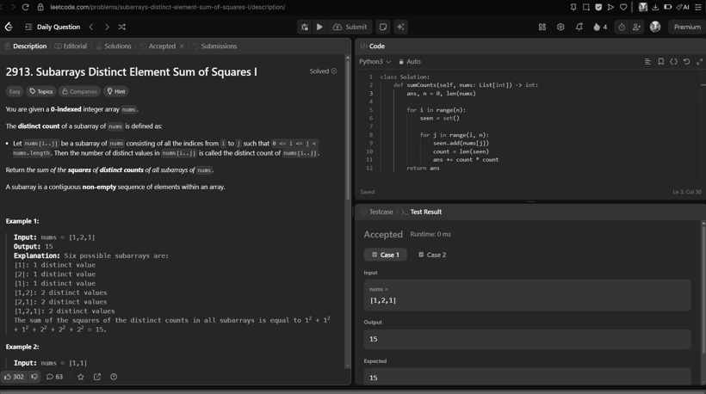
My LeetCode accepted submission (black-and-white copy).

